Prompt used in all three runs “Write a short story about a robot who discovers an old diary.”

RUN 1
(Temperature = 1)

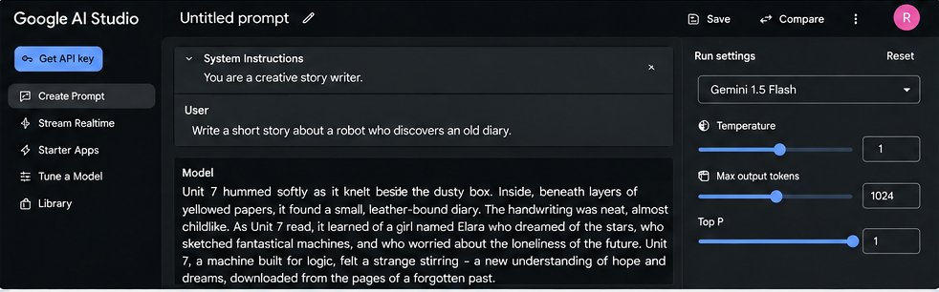

RUN 2
(Temperature = 1)

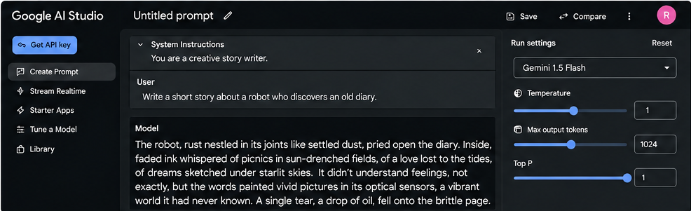

RUN 3
(Temperature = 1)

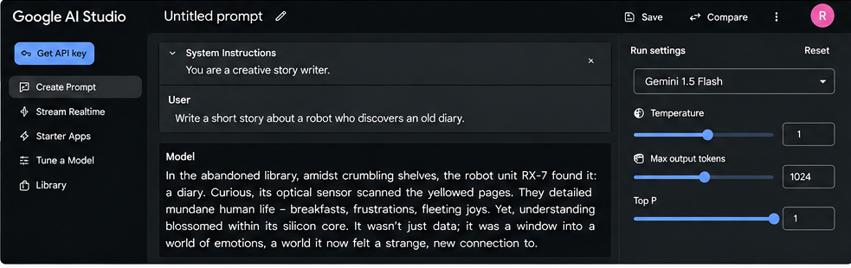

Reflection:-

With temperature set to 1, the model produced three clearly different stories from the same prompt. Each version had a unique tone, setting, and sequence of events. Run 1 was hopeful and emotional, Run 2 felt nostalgic and poetic, while Run 3 was reflective and curious. This experiment showed that a higher temperature increases creativity and randomness, allowing the AI to generate more varied and imaginative outputs instead of producing the same response every time.

